Acknowledging Orders
There are two ways to acknowledge orders individually or in bulk.
To individually acknowledge you may go through the following steps:
- Choose/Search for the order you are going to acknowledge/cancel
- Once you find the click view
- Now that you are in the order click on the Accept/Reject link and this will take you to a new page where you can either Accept or Cancel items.
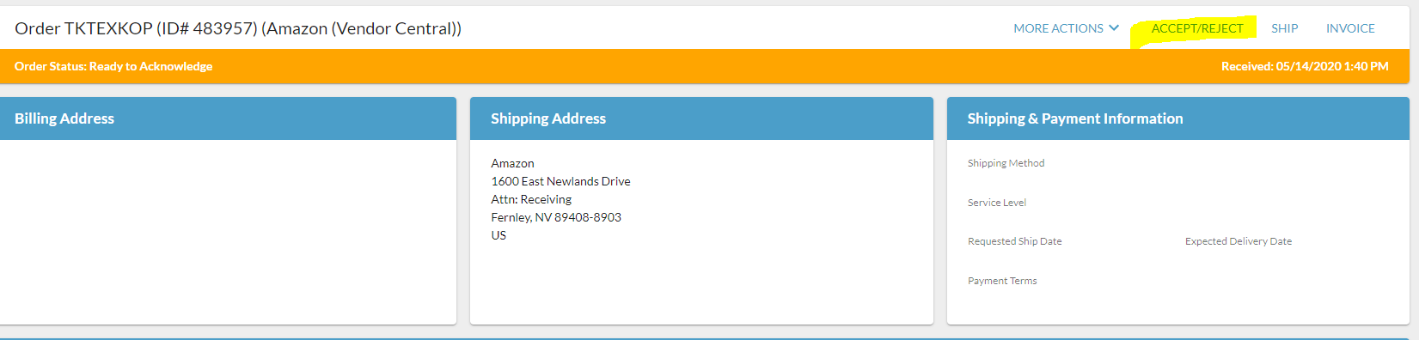
- If you are accepting all items just hit submit. Or you may accept and cancel per line and add cancellation reasons, then hit submit. This will trigger the EDI to Amazon
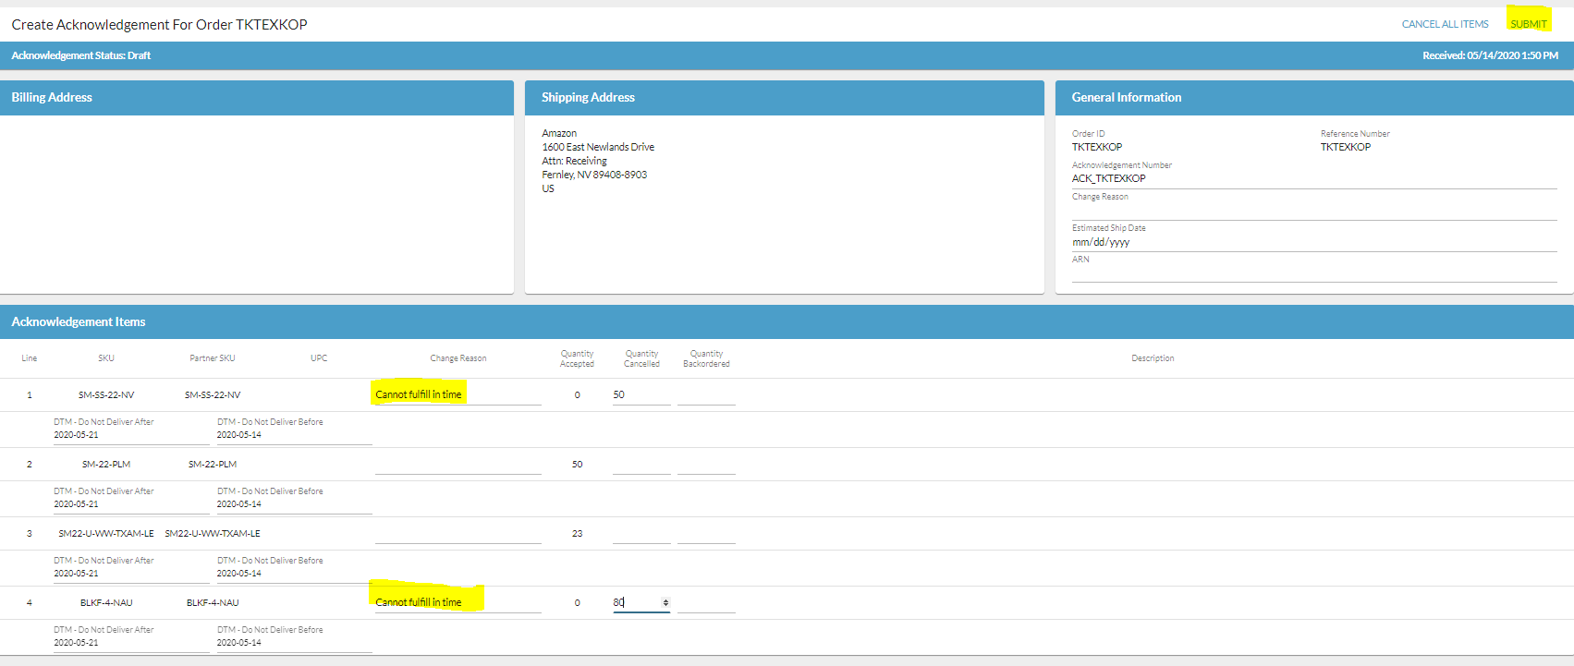
Acknowledging in Bulk
- Select the order/orders you want to acknowledge
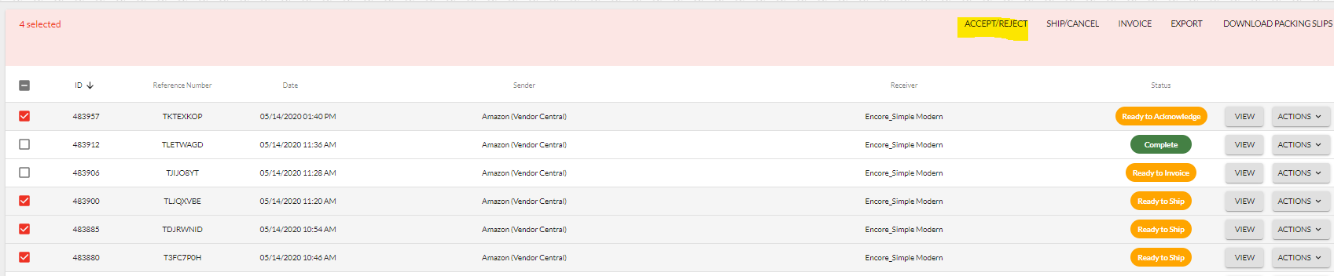
- If you are accepting everything in the order just hit submit, if you are cancelling any then fill in the quantity canceled and cancel reason and then hit submit
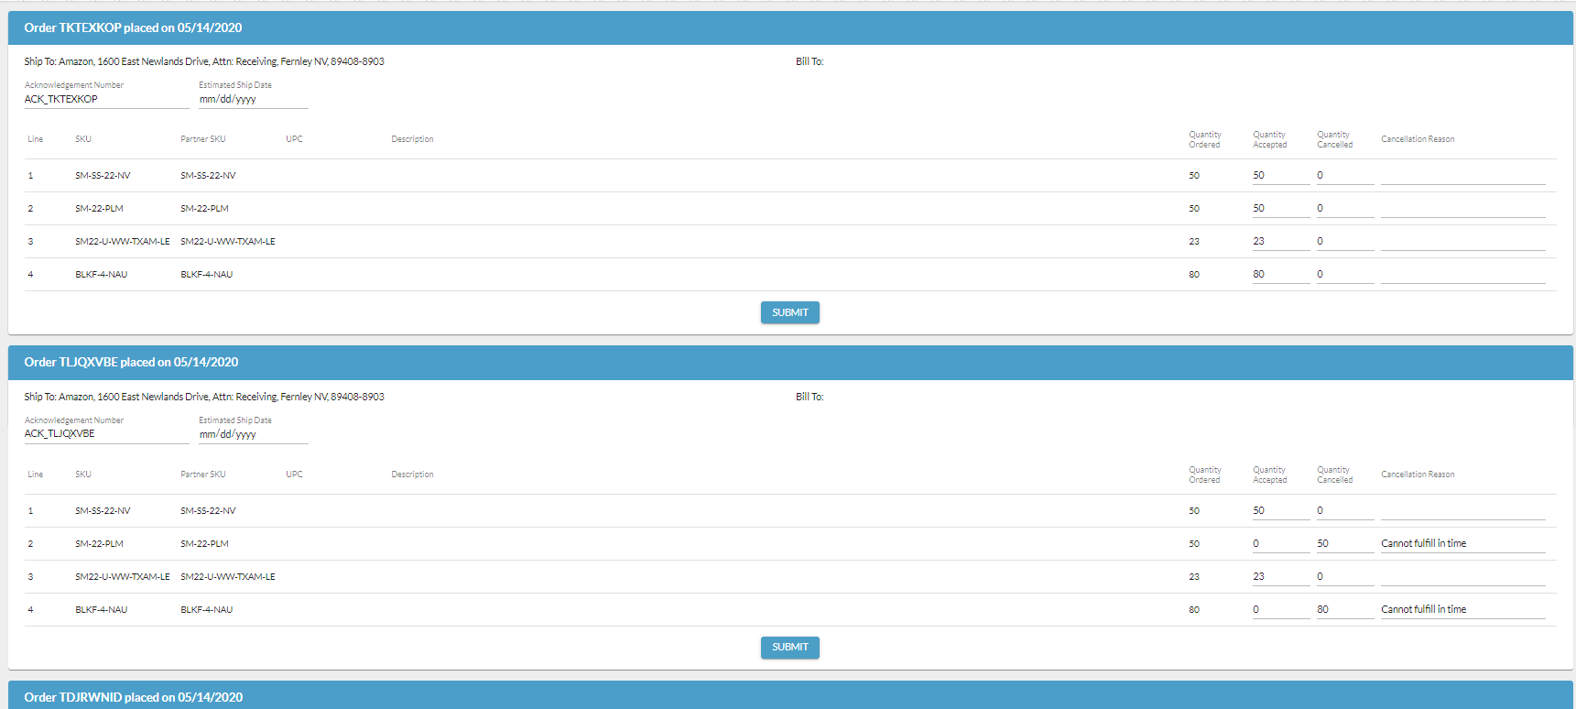

Creating a 753 / 754
- When you are ready to send the routing instructions you must find the order and click Ship in under actions, or you may click into the order and click ship
- Your Ship From address will be prepopulated. If you need to update this you may do so in the portal under settings > account information > Ship From address. Please note the address code comes from Vendor Central so please do not remove as it is required on the 753.
- You can also create default boxes that you wish to use by going to settings > shipment options and choose boxes. Click New box, name it so it is easily identifiable, fill in the dimensions and save it
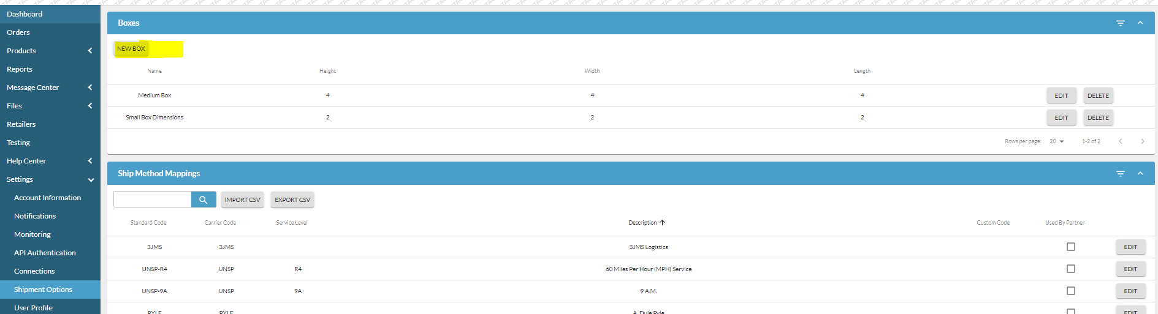
- Then when you go to create your boxes in the portal you can choose the box from the drop down or create your own
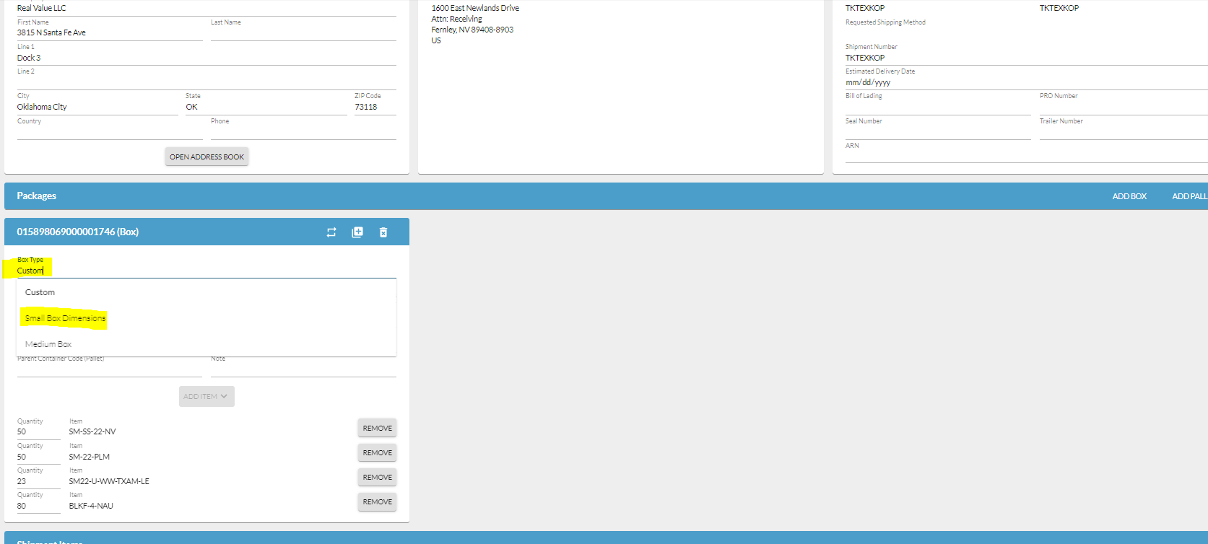
- The following information is required for the 753
  - Estimated Ship Date
  - Weight, Height, Length, Width
  - Ship From address and address code > defaulted
  - All items that are being shipped
  - Hit Submit
  - The Shipment will then go into a status of Awaiting 754
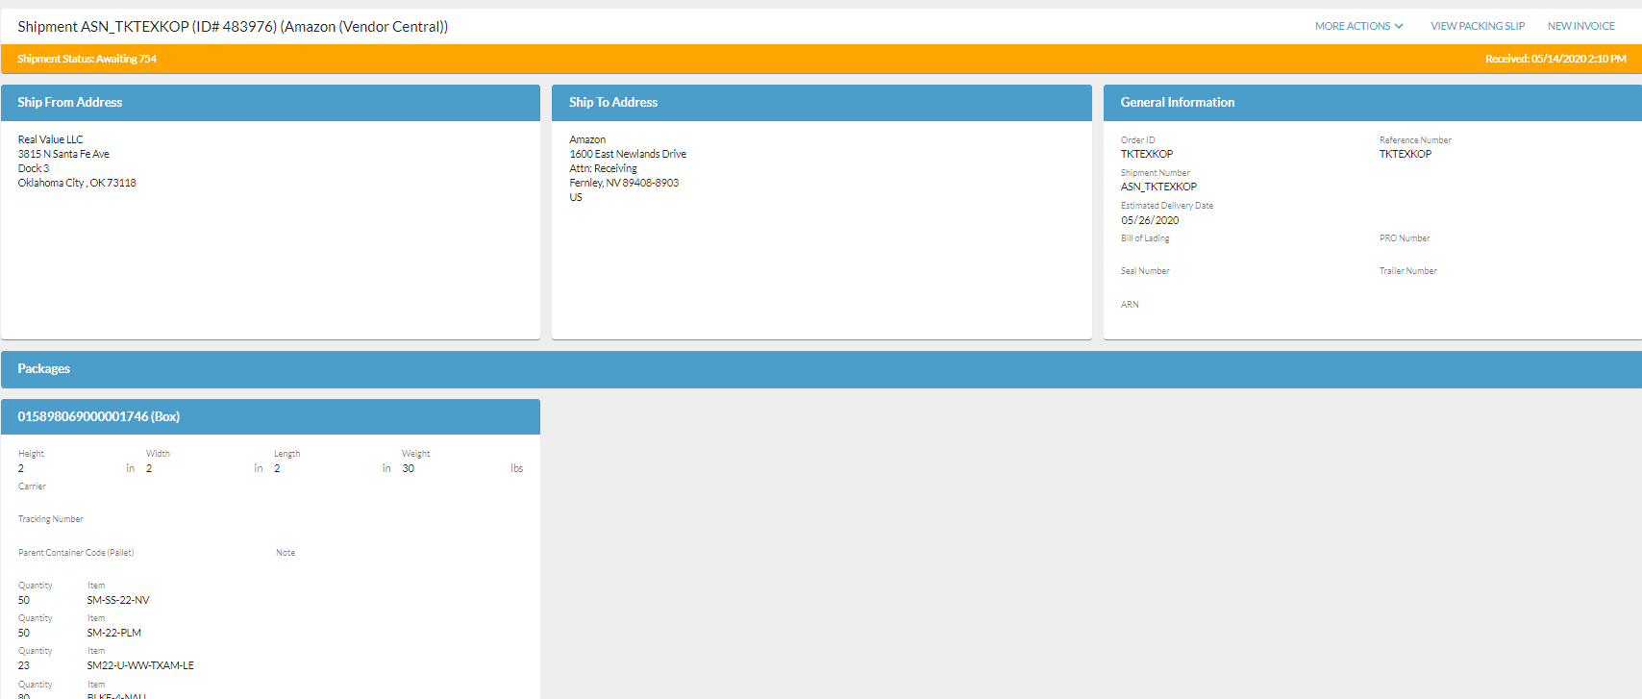
  - Once that has been sent out, you can then print the GS128 labels by going to more actions and GS128. This will give you labels for all the boxes that you created on the shipment request
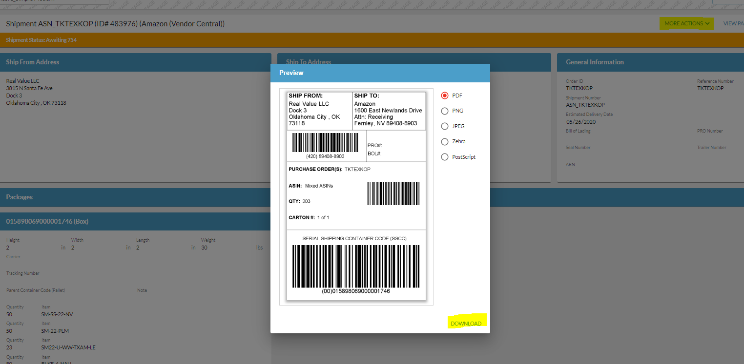
- You will also want to subscribe to receive an email notification when the Instructions (754) is sent. To subscribe go to settings > notifications > and choose Routing Instructions and save. NOTE this has to be done on the user level if you want to receive the notification
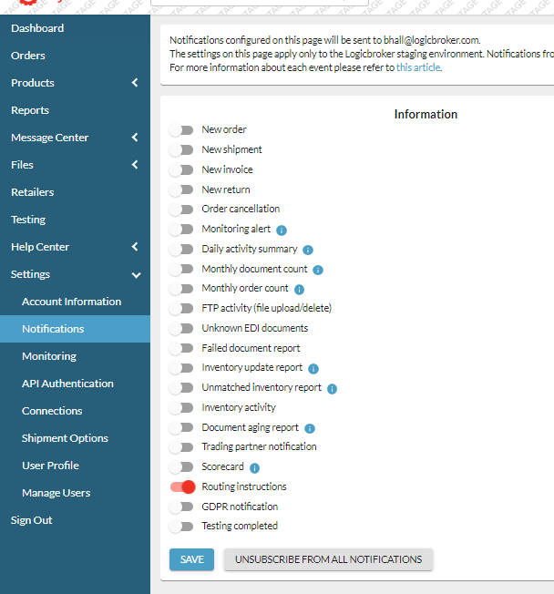
- The email will have all the instructions but they are also available within the portal within the shipment document that you created under Events.
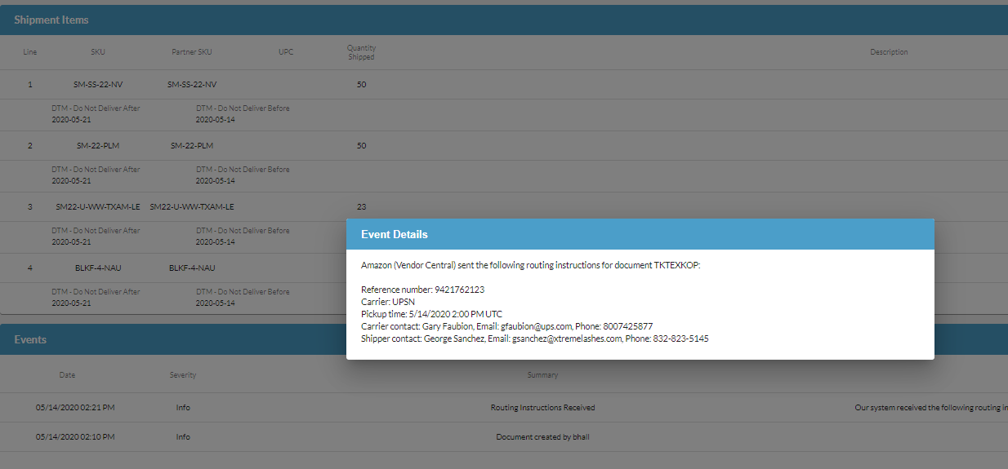
- Also the document will move to a 754 received status

Adding in Shipment information
- Once the shipment is with the carrier Amazon needs to be sent an 856 document which confirms that shipment is on it’s way
- To do this, search for the order and click view on the shipment
- The Carrier will be populated with what came in on the instructions, so you will just need to insert the assigned carrier/tracking number given by amazon in the Tracking number field for EACH box
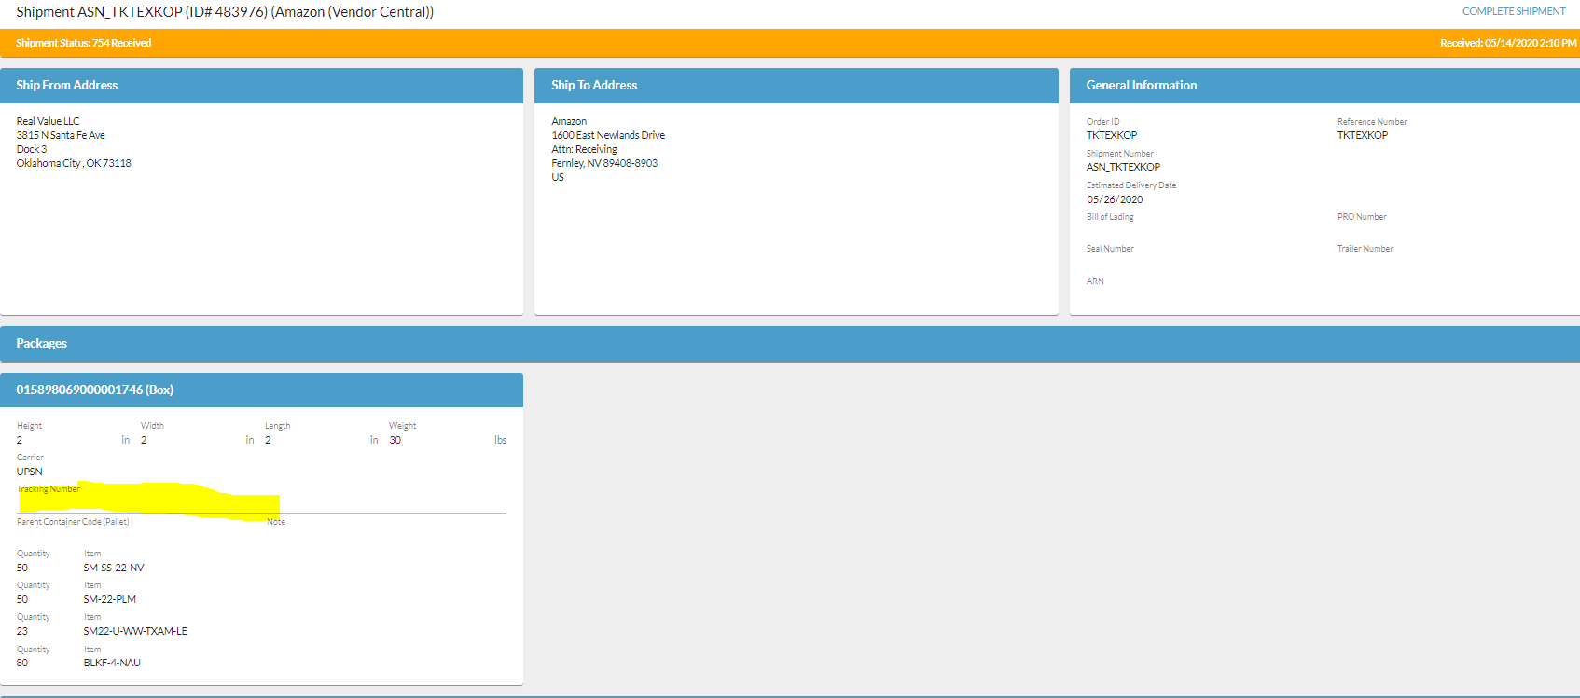

- Click Complete Shipment, The EDI will go out to Amazon
- The document will move to Complete Status and an invoice will also be generated

